**Guest Hub**



**Submitted By:**

Shahzad Ashraf (BCS02123119)   
Fahad Shahzad Baig (BCS02123420)

Qurat-Ul-Ain (BCS02123704)

**Project Supervisor**

Prof. Abid Bashir

Final year project submitted in partial fulfillment of requirements for the degree of

**Bachelors in Computer Science**

**The University of Lahore**

**Lahore, Pakistan**

10 February, 2016

**Acknowledgement**

By the Grace of ALLAH almighty we successfully completed the project efficiently and effectively. We would like to express my gratitude and appreciation to all those who gave us the possibility to complete this document.

This Manuscript was partially supported with the help of ours supervisor Prof. Abid Bashir and Mam Yasmeen Khatoon for their valuable comments to moderated and improved this document significantly. There stimulating suggestions and encouragements helped us to improve and complete a effective project.

We also thanks friends and all related persons who provided insight and expertise that greatly assisted the research and improvising of our project.

Last but not least we thanks our Family for their prayers and such a big support which make us capable of what we are and will be in our future.

**Abstract**

Now a days users are so much concerned about their data privacy because they need to share their Smartphones with other people for different purposes. There are multiple users of every smartphone (colleagues, friends and family).

So we are introducing a new application which will work with multiple security/privacy profiles differentiated on the authentication that user will provide on screen activation. User can define privacy rules for each profile. So if you are authenticated as Main administrator then you don’t have to re-authenticate again and again. And if you have to share your smartphone with someone then give them authentication of guest profile. Application will provide multiple security profiles so that user can set different security profiles for different groups of people with whom they share their Smartphone. With this application users will define their smartphone custom security.

Single click access to all protected apps when using the master pin/pattern.

**Table of Contents**

List of Figures ………………………………………………………………………………………….6

Chapter No. 1 Introduction to the Problem

1.1

1. **1.1 Introduction** 2
2. **1.2.1 Problem Statement** 2
3. **1.2.2 Purpose/Objective** 2
4. **1.3.1 Existing** **Solutions:** 3
5. **1.3.2 Proposed Solution:** 3
6. **1.3.3 Modules:** 4
7. **2.1 Introduction:** 6

**2.1.1 Purpose:** 6

**2.1.2 Intended audience and reading suggestions** 6

**2.1.3 Scope:** 6

1. **2.2 Overall Description** 6

**2.2.1 Product Perspective:** 6

**2.2.2 User characteristics** 7

**2.2.3 Constraints** 7

**2.3.1 Product Functions:** 7

**2.4 Functional Requirements:** 7

**2.4.5 User Classes and Characteristics:** 9

1. **2.5 Operating Environment:** 9

**2.5.1 Communication Interface:** 9

1. **2.5.2 System Feature:** 9
2. **2.6 Non-Functional Requirements:** 10
3. **3.1 System Use Case** 12
4. **3.2 Use case Diagrams** 13

**3.2.1 Add Guest** 13

**3.2.2 Edit Profile** 13

**3.2.3 Delete Profile** 14

**3.2.4 Smart Capture** 14

**3.2.5 Smart Cam Notification** 15

**3.2.6 Smart Alarm** 15

**3.2.7 Get Authorize Admin** 16

**3.2.8 Get Authorize Guest** 16

**Figure Table**

Figure 1 System Use Case 13

Figure 2 Add Guest 14

Figure 3 Edit Profile 14

Figure 4 Delete Profile 15

Figure 5 Smart Capture 15

Figure 6 Smart Cam Notification 16

Figure 7 Smart Alarm 16

Figure 8 Get Authorize Admin 17

Figure 9 Get Authorize Guest 17

Chapter No. 1

Introduction to the Problem

# **1.1 Introduction**

Everyday revolutions in technology is making human life more comfortable. Some years ago the era of technology people were using lots of gadgets for different purposes like camera for moment capturing, mobile phones for communication, video games for entertainment and so many other gadgets for ease. By passage of time technology revolutions combined these gadgets under a single casing to fit in hand, known as smartphone. Smartphones are providing ease to its users by its multiple features and applications, so it is also holding a huge amount of private data of users like (Messages, Call logs, pictures, videos & applications). This huge amount of private data make users to concern about their privacy from unwanted users of their smartphone.

A big part of smartphone’s market is using android OS. As we were talking about privacy of data, there are so many applications available on android’s play store who provide you authentication services before opening/accessing a private data/app. These application protect user’s data but also make their work slow by re-authentication again and again, and most of them can easily bypassed. So we are introducing a new application named as “Guest hub”. This application will help those who want to protect their data efficiently without re-authentication again and again. Especially beneficent for those people who share their mobile with their colleagues, friends & family.

**1.2 Project Description**

# **1.2.1 Problem Statement**

People use so many AppLocker’s and other privacy applications to secure their data but there applications increase their usage complexity by imposing lock screen on start of every application. These AppLocker’s provide single authentication for all locks so if you share that authentication with someone, he/she can access all the lock components. So there is a need of an application which smartly choose between security profiles and make privacy simple for user.

# **1.2.2 Purpose/Objective**

Users are so much concern about their privacy now a days. But privacy applications available on play store are also slowing down their performance by re-authentication or can easily bypassed and if they share their password with someone then other users can access all locked component. So this app will helpful for users, they can define user profiles with customized security options and share their smartphones with others easily. Guest Hub will select user profile by main screen-lock and set further securities according to that defined profile. Using this application people can work efficiently and securely without repeating authentication process again and again. User can share guest profiles with everyone, so user’s privacy will remain constant until he shares his administrative profile with someone. Summary of these objectives would be as follows:

* **Security:** Security is an important concern when we are designing an application whose purpose is to secure applications and data of user from unwanted users. Our application will ensure a strong profiles security as defined by user. Additional features of Smart Capture and Smart Alarm also increase security of mobile.
* **Reliability:** Reliability is another important concern which could not be allowed to go unnoticed. System should be reliable so it could gain trust of users and can be used for bigger audience. Reliability is ensured by testing phase to make sure that user will not face any bug or issue while defining and switching between profiles.
* **Performance:** Performance of an application means, it is interactive and responsive without any unwanted delays or lags. Although at time of this writing, development team might not be expert in languages of selection but they shall assure main interface and core features do not cause unnecessary delays, lag or crashes.
* **Usability:** Usability of application is important aspect of its design. The interface, which a user is shown, should be easily viewable, linear learning curve and colors should be cooler to eyes. There are various other factors which affect usability of an application. Our application will provide ease for user to define his/her security profiles.
* **Ease to User:** By implementation of this application our main objective is to provide ease to our user so that he can secure from unwanted users and at same time user can share a limited data with different guest users.

**1.3 Existing and Proposed Solutions**

# **1.3.1 Existing** **Solutions:**

During the web research, we found some existing solutions and popular application users are using but these application show some lags and limitations for users. Some are follow:

* **AppLocker:** App is not providing multiple security levels.
* **Vault:** Show lags while we switch orientation on different screens.
* **Guest Mode:** Limited with one guest profile and also don’t provide security assurance.

# **1.3.2 Proposed Solution:**

As we mention above our application “Guest Hub” will facilitate users to create different security level profiles for different people. So if they need to share their smartphone with someone, user can simply share Guest-User authentication with them and can use Admin authentication on screen lock for himself. So that’s how they will not get re-authentication screen and also get their privacy maintained. Additionally our app will overcome the security issues and flaws occurring in other apps.

# **1.3.3 Modules:**

Modules of our app are following.

* Screen lock
* Guest Mode
* Lock/Unlock App
* Smart Capture
* Smart Alarm

**1.3.4 Deliverables:**

There are many deliverables in our mobile application will be delivered after the completion of this application. Some of our Android studio, API’s, Java code, Xml or Json.

Chapter No.2

Software Requirement Specification (SRS)

# **2.1 Introduction:**

This chapter explores the purpose, scope, acronyms and references related to different concepts and definitions being described here, which are related to our application Guest Hub.

## **2.1.1 Purpose:**

This app will helpful for users, they can define user profiles with customized security options and share their smartphones with others easily. Guest Hub will select user profile by main screen-lock and set further securities according to that defined profile. User can share guest profiles with everyone, so user’s privacy will remain constant until he shares his administrative profile with someone.

## **2.1.2 Intended audience and reading suggestions**

The SRS chapter is used to inform the reader for approaching Guest Hub functionalities as their smart phone application and how they can use it efficiently; the reader will get a general understanding of the product including its functional and non-functional requirements as well and its features. Audience for whom this document is useful are:

Smart Phone Users: People who use this application and need understanding of its functionalities.

Developers: Who will use this app and also update or edit it.

## **2.1.3 Scope:**

Guest Hub will get the users interaction very quickly as compare to other AppLocker’s available for android smartphones because of its user friendly and customized security profiles. This applications will increase user’s usage efficiency along with their applications security, which is the main aspect of this Guest Hub.

# **2.2 Overall Description**

## **2.2.1 Product Perspective:**

Guest Hub is intended to provide security for smartphone users along with the efficiency of UI. We know that security systems are available in many smartphones and also there are so many other application which provide application locking, but they are not working accurately with efficiency. These existing applications provide authentication screen in front of every application user try to access and is being locked. Of-course most of these applications are frequently in use by users (Facebook, Messaging, WhatsApp, Call logs, Gallery etc.) which increase the complexity of their access to these apps. So what if administrator user authenticate one time at screen locker with its admin pin and he get access to all his applications? And when want to share his/her smartphone with someone he simply grant him Guest profile pin, so Guest user will not be able to get access of secured applications. In this way users security will remain constant along with the efficiency of UI.

## **2.2.2 User characteristics**

* User should have an android phone with minimum version of KitKat in order to run this app.
* User is concerned about his security.
* User have to share his smartphone with others.

## **2.2.3 Constraints**

* User must have android phone with minimum KitKat.
* User must disable built-in screen lock of his/her android phone.

**2.3 Specific Requirements**

## **2.3.1 Product Functions:**

Security & efficiency is the main function of Guest Hub other than these, it will provide the following features as well.

* User will be able to define guest modes in app.
* User will be identified by the screen lock.
* Admin can add guest accounts.
* Manage guest accounts and define their app access role separately.
* Smart Capture will capture front camera snap when wrong password is entered.
* Smart Alarm will alarm a sound password tries exceeds defined number of entries.
* App will manage app security with defined accessing rules by admin.
* Forget Password Security Questions.
* Google Sign-in Email recovery of forgotten password (Optional).
* Fast and smooth UI.

## **2.4 Functional Requirements:**

Main feature of Guest Hub are Admin & Guest Modes, Smart Capture, Smart Alarm. They are followed by a detailed specification of the functionality of the app.

|  |  |  |  |  |  |
| --- | --- | --- | --- | --- | --- |
| **ID** | **Name** | **Description** | **Input** | **Output** | **Basic Flow** |
| FN1 | Admin & Guest Profile | * Admin profile will be created at application first startup. * Admin can add more Guest profiles. | * Name * Pin/Pattern | * Profile created | * Click “Add Guest” or “+” at “Profile Screen”. * Enter name of profile in Dialogue appeared “Name Dialogue”. * Set Pin/Pattern on appeared “Pin/Pattern Screen”. * Confirm Pin/Pattern on appeared “Confirm Pin/Pattern Screen”. * “Profile Detail screen” will be displayed. * Click on App List to Lock/Unlock applications. * Click Save Tick to save profile. |
| FN2 | Edit Profile | * Admin can edit profiles. | * Name * Pattern | * Profile edited | * Click on existing guest profile at “Profile Screen”. * “Profile Detail screen” will be displayed. * Click on name for “Name Dialogue”. * Click on set Pin/Pattern for redefining Pin/Pattern. * Click on App List to Lock/Unlock applications. * Click Save Tick to save profile. |
| FN3 | Profile security | * Each profile lock/unlock its own application. | * Screen Lock | * Profile selected * App lock/unlock according to that profile | * Enter pin/pattern. |
| FN4 | Delete Guest | * Admin can delete an existing guest. | * Long press on profile | * Profile deleted | * Long press on a Profile. * Select Delete from settings appeared. |
| FN5 | Smart Capture | * Smart Camera will capture front cam if wrong password is entered. | * Wrong Pin/Pattern | * Snap from front Camera | * Click settings. * Turn Smart Camera switch On/Off. |
| FN6 | Smart Alarm | * User can enable/disable Smart Alarm. | * Wrong Pin/Pattern | * Alarm | * Click settings. * Turn Smart Alarm switch On/Off. * Select number of wrong entries. |

## **2.4.5 User Classes and Characteristics:**

Users of Guest Hub are those people who want to secure their application from others u users and especially beneficial for those who probably share their smartphone

With colleagues, friends and family members.

* **Customers:** User of android smartphone who use this app.
  + Main Admin or Owner of Smartphone
  + Guest Users ( Other users with whom smartphone will be shared)
* **Developers:** Those who both use the app as well as edit the app.
* **Designer:** Those who edit, use and change the design of app.
* **Smart Phone Users:** Those who only use the app not edit the app.

# **2.5 Operating Environment:**

Guest Hub will run on Android Platform Smartphones and Tablet’s with the minimum SDK Version of KitKat except Android L Series.

* Samsung
* Sony
* HTC
* Q Mobile
* G-Five
* Hawaii etc.

## **2.5.1 Communication Interface:**

* Guest Hub will communicate to database without internet. It will save all profile settings in directory folder. If user uninstall application (Allowed with in admin profile), protection of all profiles will be removed automatically.
* Guest Hub will send forgotten password request to the online server so a reset code can be sent to users email address.

# **2.5.2 System Feature:**

* Guest hub will protect the applications which are not authorized to that profile.
* After screen lock authentication profile will be selected along with it the security settings.
* Smart Capture will capture front camera snap when wrong password is entered.
* Smart Alarm will alarm a sound password tries exceeds defined number of entries.
* Manage Guest profiles with different accessing rules defined by Admin.
* Forget Password Security Questions.
* Google Sign-in Email recovery of forgotten password (Optional).

# **2.6 Non-Functional Requirements:**

* **User Satisfaction:** Our App will be user satisfactory in the way that user will feel comfortable when using this app. Because whatever the app will it should be user friendly.
* **Response Time:** Response is also a very key feature of our app and our app will be very satisfactory related to Response time.
* **Error Handling:** We will use Exceptional Handling for detection of errors and avoid any kind of Inconvenience.
* **User Friendliness:** Our app will be user friendly and it’s also provide help in every possible way to user in every step user perform. We also provide Help document which will be available Life time for user which facilitate user in every possible way.
* **Reliability:** Our App is reliable in every perspective which connects user and Interface of App.
* **Portability:** Our App will definitely portable only user have to connect to internet once when downloading it after that user can use it where user wants without any connection.

Chapter No.3

Analysis [Use Case Description and Use Case Model]

# **3.1 System Use Case**

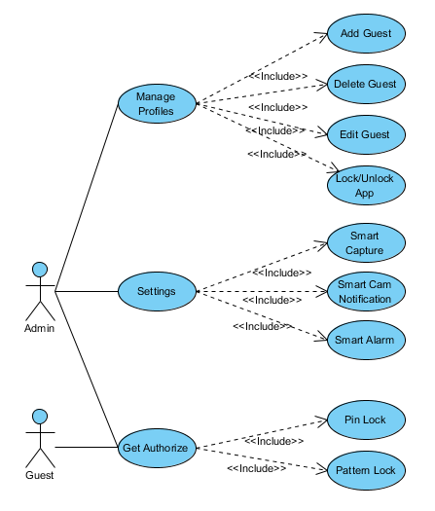

Figure 1 System Use Case

# **3.2 Use case Diagrams**

## **3.2.1 Add Guest**

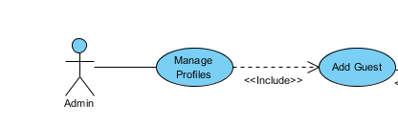

Figure 2 Add Guest

|  |  |
| --- | --- |
| Use Case | Add Guest |
| Actor | Admin |
| Description | Admin can add a new guest. |
| Precondition | Authorized as admin successfully. |
| Basic flow of event | 1. Click “Add Guest” or “+” at “Profile Screen”. 2. Enter name of profile in Dialogue appeared “Name Dialogue”. 3. Set Pin/Pattern on appeared “Pin/Pattern Screen”. 4. Confirm Pin/Pattern on appeared “Confirm Pin/Pattern Screen”. 5. “Profile Detail screen” will be displayed. 6. Click on App List to Lock/Unlock applications. 7. Click Save Tick to save profile. |
| Alternative events | If Pin/Pattern not matched then re-enter Pin/Pattern. User can press cancel button to cancel progress. |
| Post Condition | Profile added successfully. |

## **3.2.2 Edit Profile**

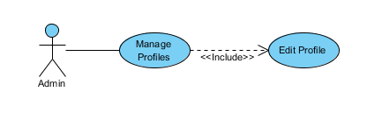

Figure 3 Edit Profile

|  |  |
| --- | --- |
| Use Case | Edit Guest |
| Actor | Admin |
| Descrciption | Admin can edit an existing guest. |
| Precondition | Authorized as admin successfully and profile must exist before. |
| Basic flow of event | 1. Click on existing guest profile at “Profile Screen”. 2. “Profile Detail screen” will be displayed. 3. Click on name for “Name Dialogue”. 4. Click on set Pin/Pattern for redefining Pin/Pattern. 5. Click on App List to Lock/Unlock applications. 6. Click Save Tick to save profile. |
| Alternative events | If want to cancel changes click cancel. |
| Post Condition | Guest profile changes saved successfully. |

## **3.2.3 Delete Profile**

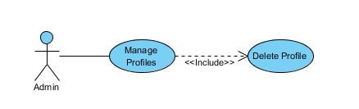

Figure 4 Delete Profile

|  |  |  |
| --- | --- | --- |
| Use Case | Delete Guest |  |
| Actor | Admin |  |
| Description | Admin can delete an existing guest. |  |
| Precondition | Authorized as admin successfully and profile must exist before. |  |
| Basic flow of event | 1. Long press on a Profile. 2. Select Delete from settings appeared. |  |
| Alternative events | User can select cancel from settings. |  |
| Post Condition | Guest profile deleted successfully. |  |

## **3.2.4 Smart Capture**

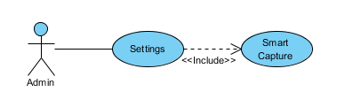

Figure 5 Smart Capture

|  |  |
| --- | --- |
| Use Case | Smart Capture |
| Actor | Admin |
| Description | Smart Camera will capture front cam if wrong password is entered. |
| Precondition | Device has front camera. |
| Basic flow of event | 1. Click settings. 2. Turn Smart Camera switch On/Off. |
| Alternative events | If Device don’t have front camera this option will be disabled. |
| Post Condition | Turn Smart Capture On/Off |

## **3.2.5 Smart Cam Notification**

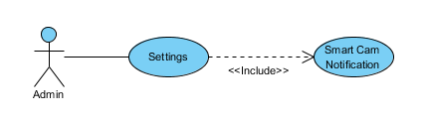

Figure 6 Smart Cam Notification

|  |  |
| --- | --- |
| Use Case | Smart Capture Notification |
| Actor | Admin |
| Description | User can enable/disable Smart Capture Notification. |
| Precondition | Smart Capture must be enabled. |
| Basic flow of event | 1. Click settings. 2. Turn Smart Capture Notification switch On/Off. |
| Alternative events | If Smart capture is not enabled this option will be disabled. |
| Post Condition | Turn Smart Capture Notification On/Off |

## **3.2.6 Smart Alarm**

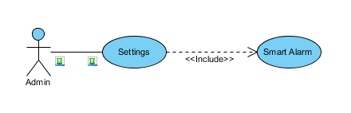

Figure 7 Smart Alarm

|  |  |
| --- | --- |
| Use Case | Smart Alarm |
| Actor | Admin |
| Description | User can enable/disable Smart Alarm. |
| Precondition | None |
| Basic flow of event | 1. Click settings. 2. Turn Smart Alarm switch On/Off. 3. Select number of wrong entries. |
| Alternative events | None |
| Post Condition | Turn Smart Alarm On/Off |

## **3.2.7 Get Authorize Admin**

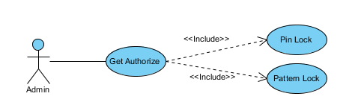

Figure 8 Get Authorize Admin

|  |  |
| --- | --- |
| Use Case | Get Authorize |
| Actor | Admin |
| Precondition | Predefined Pin/Pattern |
| Basic flow of event | 1. Start App 2. Enter Pin/Pattern |
| Alternative events | If Pin/Pattern is wrong try again |
| Post Condition | If successful then profile will be selected.  If successful logged in to App. |

## **3.2.8 Get Authorize Guest**

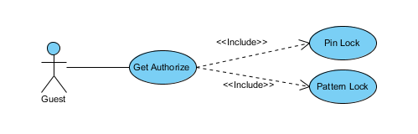

Figure 9 Get Authorize Guest

|  |  |
| --- | --- |
| Use Case | Get Authorize |
| Actor | Guest |
| Precondition | Predefined Pin/Pattern and profile |
| Basic flow of event | Enter Pin/Pattern |
| Alternative events | If Pin/Pattern is wrong try again |
| Post Condition | If successful then profile will be selected. |